Kids Code Hour of Code - addition calculator

Activity:

In this activity, students will design a quiz in which a math question is given. If the player answers correctly, a point will be awarded. However, if the answer is incorrect, two points will be deducted. Students will use **variables**, **randomization**, and **loops**.

Learning Objectives:

* Students will learn how addition can be applied to their code
* Students will learn how to use RNG
* Students will be able to use variables
* Students will be able to add user input using scratch

Materials:

* Finished project: <https://scratch.mit.edu/projects/873838441>
* Starter project <https://scratch.mit.edu/projects/879594913>

Coding Time!

Step 1: establishing the start of your code

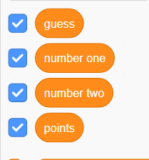

* Create four variables:
  + Number one
  + Number two
  + guess
  + Points
* Add a “when clicked” block
* Right below the “when clicked” block, set the variable “points” to 0

Step 2: Creating Random Numbers and Getting User’s Guess

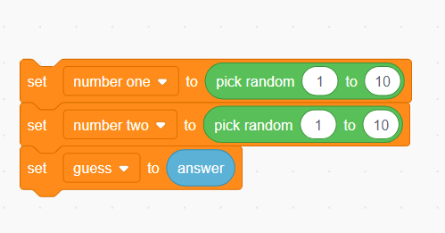

* Set the variables “number one” and “number two” to both pick a random number between 1 and 10
* Add in the “answer” block in the sensing tab
  + **this block is equal to what the user typed in
* Set the variable “guess” equal to answer
  + This assigns the user input to the variable “guess”

Step 3: adding “ask” and “if-else” functions

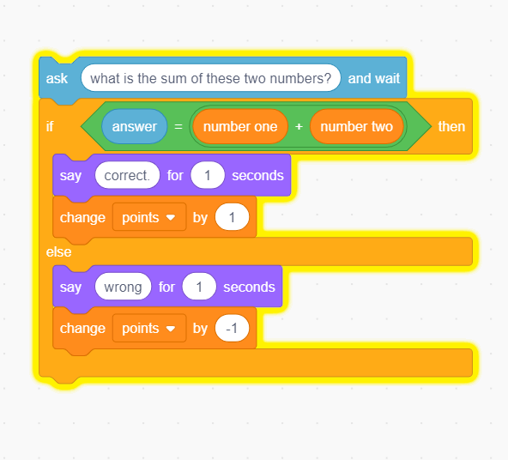

* Add the “ask” function in the sensing tab and make it so that it asks the user what the sum of the two numbers are
* Next, create an if-else statement that will determine if the user’s input (the guess variable) is equal to the correct answer
  + If the guess is right, make sure that the text “correct” is printed. If the guess is wrong, make sure that the text “incorrect” is printed.
  + Use the change variable function to change the values of the variables depending on if the guess was correct or incorrect

**Step 4: The Forever Loop**

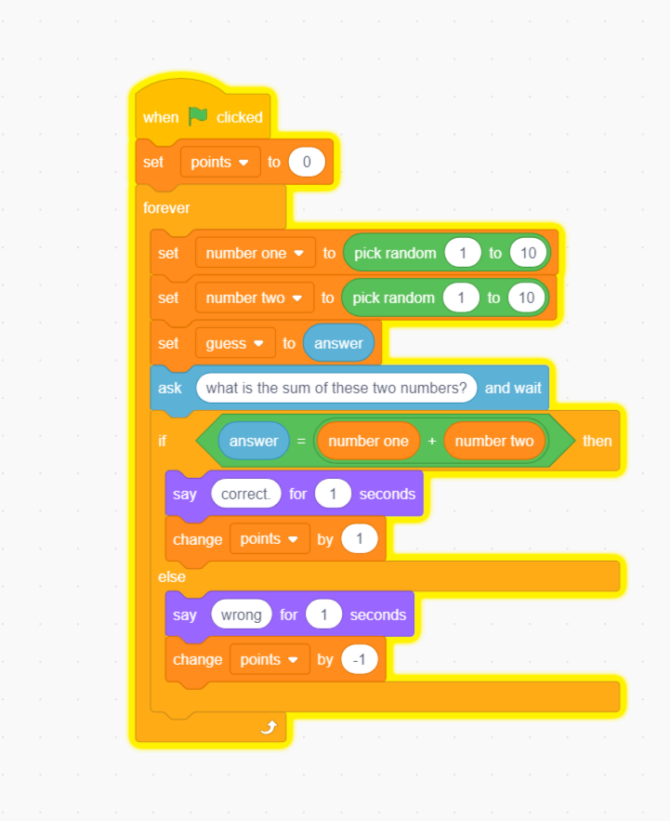

* Add forever loop that encompasses all but the “set points to zero” function

Congratulations, you have just completed an Hour of Code!